Supplementary Information
Optimal interfacial topological Hall effect platform in van der Waals CrTe₂/Bi₂Te₃ heterostructures
Xiaoqian Zhang^{1,2#}, Siddhesh C. Ambhire^{3#}, Qiangsheng Lu^{2#}, Wei Niu⁴, Jacob Cook², J. S. Jiang⁵, Deshun Hong⁵, Wenqing Liu^{1,6}, Liang He¹*, Rong Zhang¹, Steven S.-L. Zhang³*, Yongbing Xu^{1,7}*, Peng Li⁸*, Guang Bian²*

Contents:
Ⅰ. ARPES characterization of the CrTe₂/Bi₂Te₃ heterostructure
Ⅱ. Extract ρ_{THE} from Hall resistivity at different temperatures
Ⅲ. Additional transport results of the CrTe₂/Bi₂Te₃ heterostructure
Ⅳ. Ruling out the possibility of two-channel AHE
Ⅴ. Effective manipulation of magnetic skyrmions by pulse current
ⅤI. Ginzburg-Landau theory for interfacial skyrmions

Ⅰ. ARPES characterization of the CrTe₂/Bi₂Te₃ heterostructure
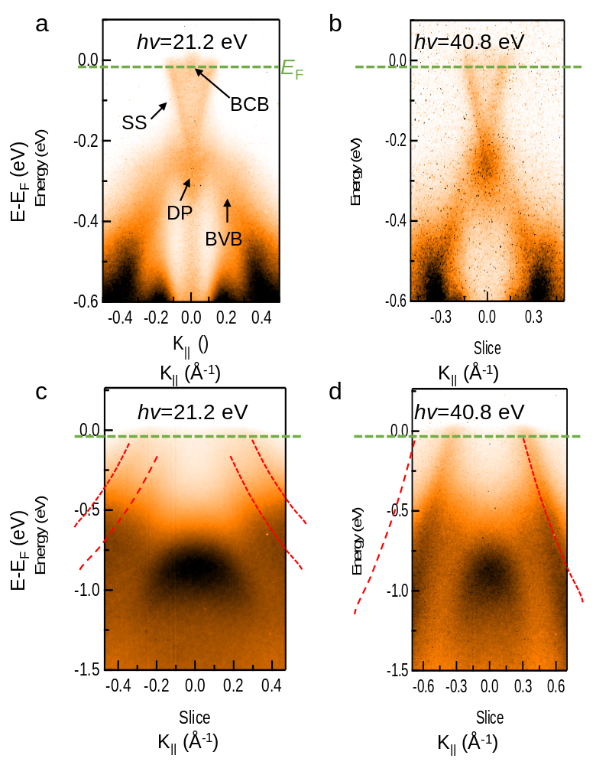
Figure S1. Electronic structures of CrTe₂/Bi₂Te₃ bilayer. From (a) to (d), ARPES spectra of Bi₂Te₃ (111) taken at hv = 21.2 eV (a) and 40.8 eV (b) as well as CrTe₂ thin film on Bi₂Te₃ with a photon energy of 21.2 eV (c) and 40.8 eV (d) along M–Г–M direction, respectively. The red dotted lines denote the hole pockets of CrTe₂. The green dashed line indicates the position of the Fermi level (E_{F}). The surface states do not change in size and shape under different photon energies.

Ⅱ. Extract ρ_{THE} from Hall resistivity at different temperatures
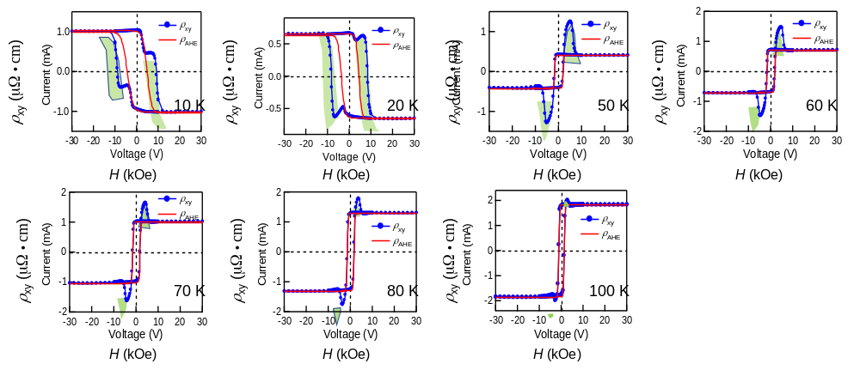
Figure S2. THE and AHE components by tanh fitting. Field dependence of Hall resistivity at different temperatures with subtraction of ordinary Hall term. Contributions from AHE and THE terms are marked by red solid lines and light green area, respectively. The fitting quality is perfect for all the measured temperatures.

Ⅲ. Additional transport results of the CrTe₂/Bi₂Te₃ heterostructure
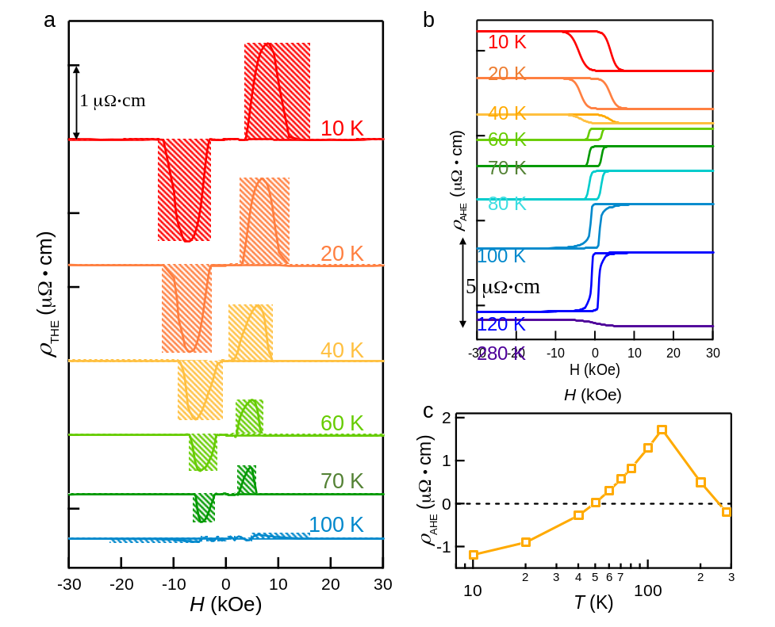
Figure S3. Reproducibility of THE in CrTe₂/Bi₂Te₃ system. (a) ρ_{THE} and (b, c) ρ_{AHE} at temperature between 10 K and 280 K is taken from additional CrTe₂/Bi₂Te₃ device. Notably, the hump-like THE signal and sign-change in AHE signal are both repeatable.

Ⅳ. Ruling out the possibility of two-channel AHE
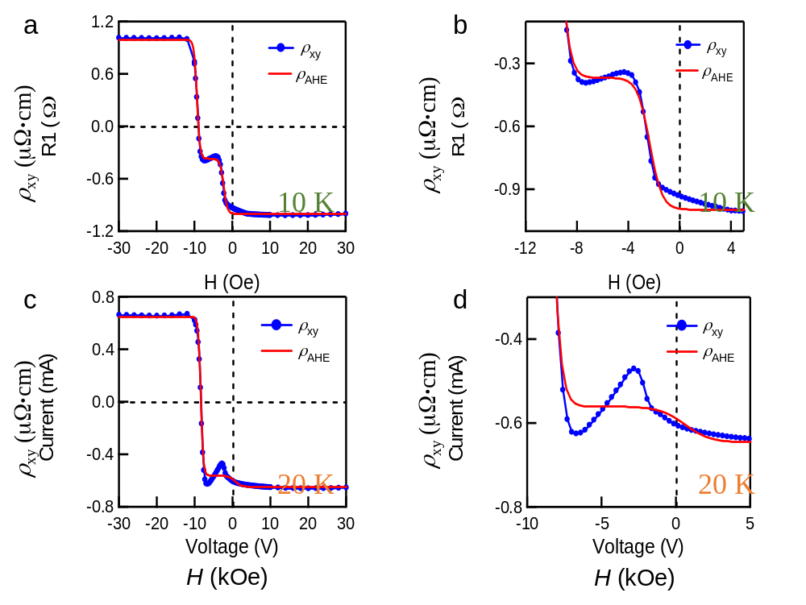
Figure S4. Two-channel AHE fitting. (a,c) An overall view and (b,d) enlarged view of the two-channel AHE fitting using double-tanh function. A simple linear superposition of two magnetic hysteresis loops can’t match well with the experimental curves of CrTe₂/Bi₂Te₃ bilayer at 10 K and 20 K, particularly in the hump features.
The fitted two-channel AHE (red solid line) shows a two-step magnetic switching behavior and a plateau in between. Notably, the hump-like features in CrTe₂/Bi₂Te₃ bilayer can’t be fit well with double-tanh functions, ruling out the possibility of mixed magnetic signals from two AHE channel with unequal H_{C}. Conversely, the emerged skyrmions or chiral magnetic bubbles can’t be ignored.

V. Effective manipulation of magnetic skyrmions by pulse current
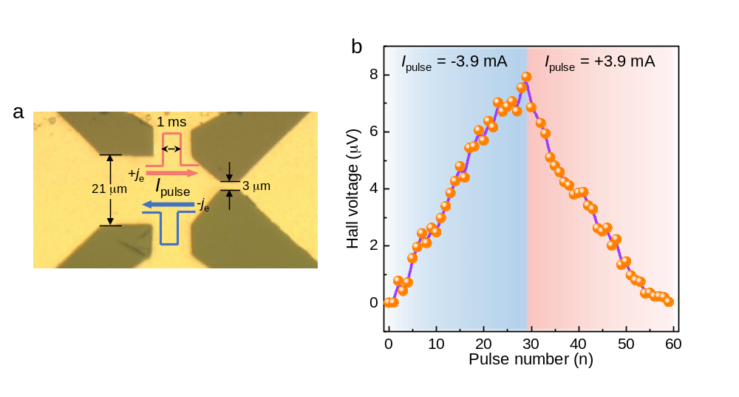
Figure S5. Experimental depinning and motion of magnetic skyrmions. (a) An optical image of a Hall bar device structure, in which a geometrical constriction is introduced for giving rise to an inhomogeneous current distribution. (b) Hall voltages were recorded after repeated 1-ms-long current pulses (j_{e}=$±$3.9 mA). It is clear that the interfacial magnetic skyrmions move following the electron flow direction.
In order to demonstrate the effective manipulation of these Néel skyrmions, a geometrical constriction is introduced into a Hall bar device of CrTe₂/Bi₂Te₃ bilayer and reliability studies were carried out by repeating pulse experiment for several times (n)^{1,2}. Upon passing a current of –j_{e} through the device, the left of the device develops dense skyrmions, giving rise to the increased Hall voltage, which scales linearly with the number of skyrmions. By reversing the current direction to +j_{e}, the skyrmions are blown to the right side. Accordingly, the Hall voltage decreases. Since the topologically trivial magnetic bubbles could only shrink or elongate when driven by current, it indicates that the interfacial skyrmions in CrTe₂/Bi₂Te₃ system with well-defined chirality can be efficiently manipulated, including depinning and motion.

ⅤI. Ginzburg-Landau theory for interfacial skyrmions
The theoretical magnetic phase diagram (Fig. 4c) and the corresponding topological charge density (Fig. 4b) in the field-temperature plane were obtained by computing the spatial average of the following magnetic free-energy density functional
$f\left[m\left(r\right)\right]=f_{GL}\left[M\right]+{A_{ex}\left(∇m\right)}^{2}-M_{S}m∙H+\left(K_{d}-K_{u}\right)m_{z}^{2}$
$+D\sum_{i=1}^{2}{\left(\hat{z}×{\hat{x}}_{i}\right)}∙(m×∂_{i}m)$ (S1)
where $f_{GL}\left[M\right]$ contains the Ginzburg-Landau terms that confine the magnitude of the magnetization $M$ to its equilibrium value $M_{S}$ at a given temperature T, $A_{ex}$ is the exchange stiffness, $m\left(r\right)$ is a unit vector denoting the direction of the local magnetization, $K_{d}\left(=2πM_{S}^{2}\right)$ and $K_{u}$are, respectively, the demagnetization energy coefficient and the perpendicular anisotropy coefficient, $D$ is the DMI coefficient, ${\hat{x}}_{1}$, ${\hat{x}}_{2}$, and ${\hat{x}}_{3}$ refer to $\hat{x}$, $\hat{y}$, and $\hat{z}$ (surface normal is along the $\hat{z}$ direction) respectively, and $∂_{i}$ is the shorthand notation for $∂/∂x_{i}$. The last term on the RHS of Eq. (S1) characterizes the interfacial DMI^{3,4} in the continuum limit.
Magnetic energies of specific magnetic structures for a given temperature and magnetic field were calculated by minimizing the averaged free energy density (S1) with corresponding magnetization profile $m\left(r\right)$. We considered two typical nontrivial magnetic structures that may appear in systems with DMI, namely, a spin helix and a skyrmion lattice (SkX). For the helix state, without loss of generality, we assumed the spatial variation of the magnetization was along the x-axis so that the general profile can be written as
$m_{h}=\left[\sin{Θ\left(x\right)}{,0,\cos{Θ\left(x\right)}}\right]$, (S2) where $Θ\left(x\right)$ can be described by a simple linear profile $Θ\left(x\right)=2πx/l_{h}$ with $l_{h}$ the period of the helix determined by minimizing the averaged free energy density (S1). For the SkX, we considered a hexagonal packing of individual Neel-type skyrmions with the following spatial profile
$m_{sk}=\left[\cos{ϕ}\sin{Θ\left(r\right)},\sin{ϕ}\sin{Θ\left(r\right)},\cos{Θ\left(r\right)}\right]$, (S3)
where $r=\left(x,y\right)=r\left(cosϕ,sinϕ\right)$, and the area between skyrmions was assumed to be uniformly magnetized. To take into account both skyrmions and chiral skyrmion bubbles^{5,6}, we considered a generalized linear spatial profile for $Θ\left(r\right)$, i.e.,
$Θ\left(r\right)=\left\{\begin{matrix}π, (r≤r_{c}) \\ π\left(1-\frac{r-r_{c}}{d_{w}}\right), (r_{c}<r<r_{c}+d_{w}) \\ 0, \left(r_{c}+d_{w}≤r≤R_{sk}\right)\end{matrix}\right.$ , (S4)
where $r_{c}$ is the radius of the skyrmion core, $d_{w}$ denotes the width of the chiral domain wall along the radial direction, and $R_{sk}$ is the radius of the skyrmion.
The following materials parameters were used in the numerical calculation: D₀ = 0.006 J/m³, T_{C} = 300 K, M₀ = 362 emu/cm³, K_{u} = 3.16 × 10⁵ J/m³, A_{ex} = 6.5 × 10⁻¹¹ J/m, where T_{C} is the Curie temperature of CrTe₂, D₀ and M₀ represent the DMI coefficient and the saturation magnetization at temperature T=0 K, respectively. As the THE resistivity was measured up to 80 K (much lower than the Curie temperature), the temperature dependence of the magnetization may be well described by the Bloch T^{3/2} law, i.e., $M_{S}=M_{0}\left[1-{\left(\frac{T}{T_{c}}\right)}^{\frac{3}{2}}\right]$. We have also taken into account the temperature dependence of the DMI coefficient $D\left(T\right)=D_{0}{\left[M_{S}/M_{0}\right]}^{5}$ which was observed recently⁷.

References
1 Maccariello, D. et al. Electrical detection of single magnetic skyrmions in metallic multilayers at room temperature. Nat. Nanotechnol. 13, 233-237 (2018).
2 Jiang, W. et al. Blowing magnetic skyrmion bubbles. Science 349, 283-286 (2015).
3 Moriya, T. Anisotropic Superexchange Interaction and Weak Ferromagnetism. Phys. Rev. 120, 91-98 (1960).
4 Dzyaloshinskii, I. E. A termodynamic theory of “weak” ferromagnetism of antiferromagnetics. J. Phys. Chem. Solids 4, 241-255 (1958).
5 DeBonte, W. J. Properties of thick‐walled cylindrical magnetic domains in uniaxial platelets. J. Appl. Phys. 44, 1793-1797 (1973).
6 Zhang, S. S. L. & Heinonen, O. Topological Hall effect in diffusive ferromagnetic thin films with spin-flip scattering. Phys. Rev. B 97, 134401 (2018).
7 Schlotter, S., Agrawal, P. & Beach, G. S. D. Temperature dependence of the Dzyaloshinskii-Moriya interaction in Pt/Co/Cu thin film heterostructures. Appl. Phys. Lett. 113 (2018).

